

SIMATS ENGINEERING
Saveetha Institute of Medical and Technical Sciences Chennai- 602105
Student Name: Perarasan V Reg. No.: 192521404
Course Code: CSA0804
Course Name: Python Programming Slot: D
Course Faculty: Dr. Jegatheesan A

Project Title: Civic Track: Crowdsourced Civic Issue Reporting and Resolution System
Module Photographs:
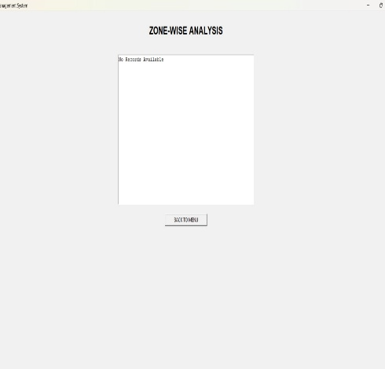
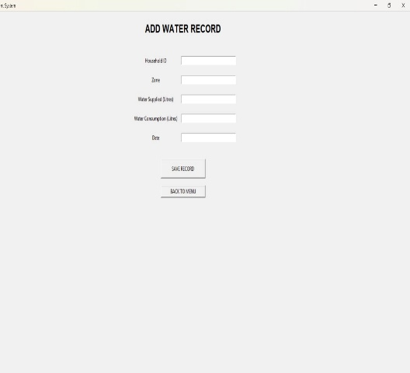
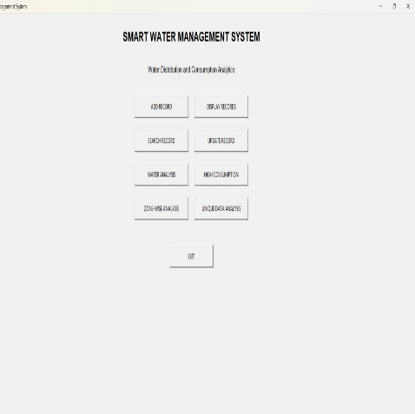
Individual Role: Designed and developed the Civic Track system for reporting, tracking, and resolving civic issues.
Module: Record Operations Search Record + Update Record
The Record Operations module is an important component of the Civic Track: Crowdsourced Civic Issue Reporting and Resolution System. It is designed to efficiently manage the civic issue records submitted by users. The module mainly provides two operations: Search Record and Update Record. The Search Record operation allows authorized users or administrators to find a particular civic complaint using details such as complaint ID, issue type, location, date, or current status. This helps users quickly access the required record without manually checking the complete database. The Update Record operation allows authorized users to modify the information associated with an existing civic issue. Administrators can update details such as issue status, assigned department, remarks, progress, and resolution information. For example, a complaint can be changed from Reported to In Progress and finally to Resolved after the issue has been addressed. Proper validation is performed before updating the record to maintain data accuracy and consistency. Together, Search Record and Update Record improve the efficiency of civic issue management. The module reduces manual effort, provides quick access to complaint information, maintains updated records, and helps administrators track the progress of reported issues. It also supports transparency by ensuring that civic complaints are properly monitored from reporting to resolution.

Student Signature Guide Signature

